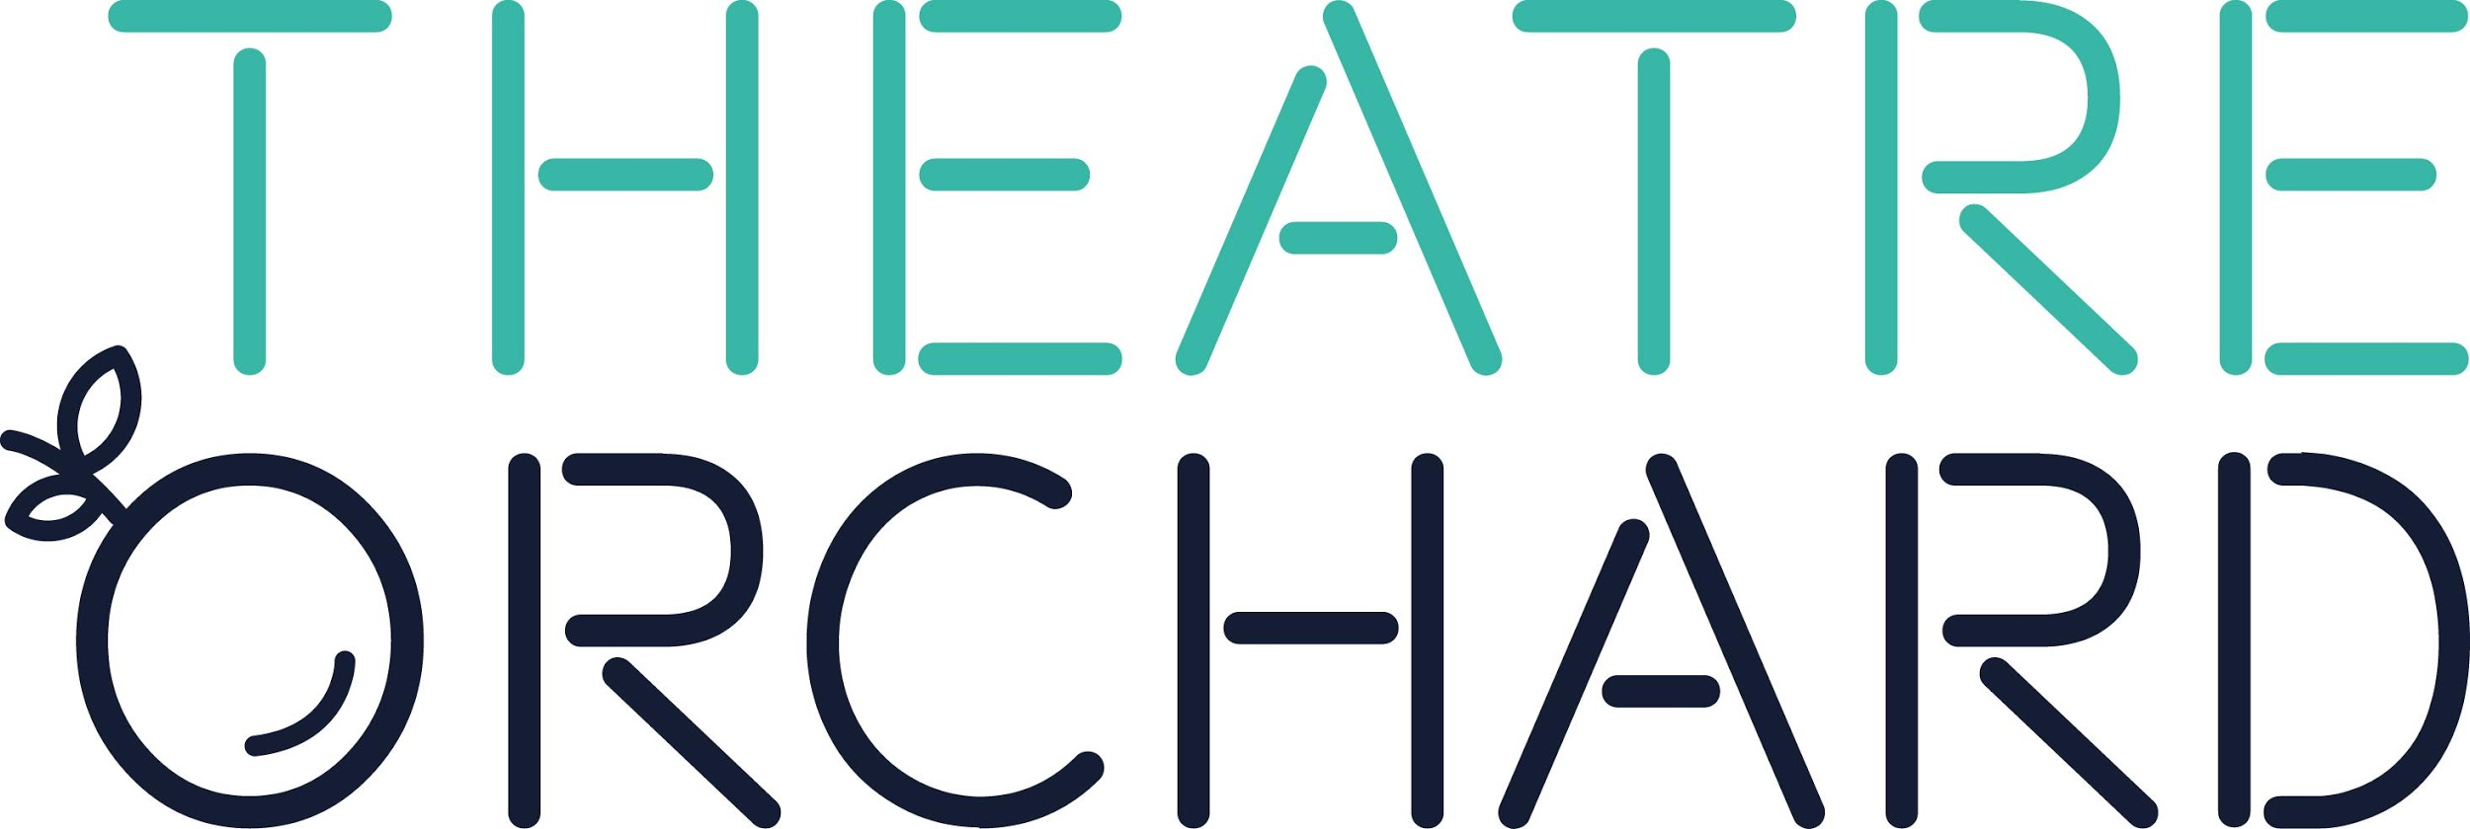

OUTDOOR ARTS ASSISTANT PRODUCER, NORTH SOMERSET

ABOUT US

theatreorchard.org.uk
Theatre Orchard is an arts development organisation that delivers an inclusive programme of professional performance and community engagement motored by the mission “Every Life in North Somerset Made Extraordinary by Live Arts”.

cultureweston.org.uk
Culture Weston is a new initiative managed by Theatre Orchard that places cultural activity and opportunity at the heart of the town’s daily life and future growth.

withoutwalls.uk.com
This post is part-funded by Without Walls who support excellence and innovation in outdoor arts.

JOB PURPOSE

To support the administration, development and delivery of an outdoor arts programme in North Somerset
Diversify and expand participation and audiences for outdoor arts in Weston-super-Mare and wider North Somerset.

REPORTS TO
Culture Weston Manager

WORKS WITH
Theatre Orchard and Culture Weston teams, in consultation with Without Walls

SALARY
£20,000 p/annum freelance rate @ 3 days per week. 1 year contract.

THE ROLE

We are seeking an enthusiastic individual to join our small but committed team. This role will encompass a range of responsibilities connected to developing and enabling inspirational and inclusive outdoor arts provision.
We’re not looking for a certain level of experience, you might be just starting out or have years of experience, or be somewhere in between. We’re most interested in is your enthusiasm, passion and aptitude. You will have your own areas of responsibility, which are outlined below, but what you do will also be shaped by what you enjoy and what you can contribute, as well as what we need.
Every day will be different, but you will never be asked to do anything that you haven’t been properly trained, or supported to do, or are not comfortable doing. But you will also be expected to be the sort of person who gets excited about learning new things. We are always learning and trying new things at Theatre Orchard and Culture Weston and we’ll provide support, training and mentoring to support your growth and developing in the role; so we’re looking for people who are excited about the prospect of the new, the different, the challenging.
You will:
- build on Theatre Orchard and Culture Weston’s current community partnerships and make new connections with isolated and under-represented communities
- help to extend Culture Weston and Theatre Orchard’s cultural offer in outdoor settings with inclusivity at the heart of this new creative landscape
- enable opportunities for communities to become active creative participants
- develop approaches to breaking down barriers between artists/communities
- support the administrative processes, technical delivery and evaluation procedures that underpin programmes of work
- form new relations with non-arts festivals
- enable a variety of voices and perspectives to contribute toward the emerging events programme of Culture Weston.

JOB DUTIES AND RESPONSIBILITIES

- Support the administration, development and legacy of an inclusive outdoor arts offer for Theatre Orchard and Culture Weston
- Develop meaningful conversations with under-represented communities in Weston-super-Mare and wider North Somerset
- Develop structures for different community groups to have a voice in programming, attend performances and review work
- Research funding and partnership opportunities that will enable this programme of work to reach its full potential

PERSON SPECIFICATIONS

Key Attributes
A commitment to diversity and inclusion in the arts
Great people skills
Passion for the arts sector
Strength in building and maintaining positive relationships with community partners
Good administrative and organisational skills
A creative approach to problem solving and an ability to make things happen

Experience, Knowledge and Skills
Interest in working across different sectors
Personal and professional experience of artistic practise welcome to support this role, but not essential
Enjoys being part of a team but can also work independently

Personal qualities
Very motivated and comfortable with working in different environments
Confidence in suggesting new ideas and ways of working

Details of employment
Fixed term freelance post.
£20,000 per annum freelance rate @ 3 days per week
Flexible and remote working are welcomed, and an office space in Weston-super-Mare is also available if health and safety guidelines permit. If you are working remotely we will do our best to ensure you have the equipment you need.

HOW TO APPLY

You can apply in two ways:

- Either with a written cover letter and CV, bullet points or sub headings are good for us. You can write as much or as little as you think is useful but we’d recommend no more than one side of A4 for the covering letter and two sides of A4 for the accompanying CV.
- Or if you would prefer to talk about your experiences and how you think you’d be great for the job we are accepting video entries of up to 5 minutes long.

Both ideally will include:
● Details of your previous employment and work experience, including names of employers, dates of employment, job titles and a brief outline of your responsibilities
● Relevant educational and training qualifications
- Two references including phone and email contacts for both and information on how soon we can contact them
- A description of the barriers you face to gaining employment

The deadline for applications is 16 November 2020.
Interviews will be held week commencing 30 November.

Applications should be sent by email to admin@cultureweston.org.uk

Please write “Application for Assistant Producer” in the subject line. Please attach PDF versions of your cover letter and CV or send your video via we transfer

As an organisation we are keen to actively address issues around systemic racism through our creative work, and to diversify our staff team as part of this drive.
We positively encourage people from a variety of backgrounds with different skills, experiences and stories to apply for the post. If you have any access needs around applying for this post please contact
admin@cultureweston.org.uk or call Fiona on 07757711783

theatreorchard.org.uk
cultureweston.org.uk

