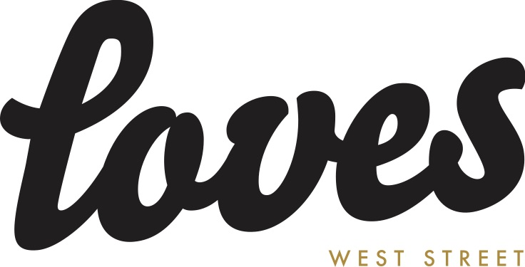

11 August 2020
Solar-powered, green gig by the sea
brings magical line-up to Weston

Music-lovers are in for a treat this Bank Holiday, as a putting green by Weston-super-Mare’s seafront is transformed into a unique outdoor music event.

Culture Weston is excited to team up with 'Loves', to bring a stunning line-up of original, live acoustic music and ‘Loves’ favourites to a solar-powered stage, featuring world-renowned musicians alongside local artists.

Ever brilliant headliners, The Magic Numbers, will be joined by Ben Ottewell from critically acclaimed band Gomez, and Weston-based musicians Alex Lipinski, who brings a classic, timeless quality to his songs and Marvin Muoneké, Weston’s winning answer to Rat Pack cool and watched by millions as a semi-finalist on ITV’s Britain's Got Talent in 2018. All the acts will be performing acoustic sets featuring original material.

Loves ‘Live on the Lawn’ takes place on Sunday 30 August at the Putting Green, Royal Sands, Weston-super-Mare, BS23 4NJ. Doors open at 4.30pm, with music from 5pm to 9.30pm and a 10pm curfew. For more information, visit cultureweston.org.uk and lovesweston.co.uk.

Following Covid-19 secure government guidelines, the event will be socially spaced to ensure audience safety and ticket numbers limited to match the small capacity of the event.

Prices start at £28 per person for safe groups of four and six, with each group allocated its own designated pod area, marked out on the lawn and people advised to bring along a picnic blanket to sit on.

Single tickets are available at £30 each, which includes deckchair seating. The recommended age is 12+ and under 18s must be accompanied by an adult. Tickets at ticketsource.co.uk/culture-weston (small booking fee applies).

Anna Southwell at Loves, said: “As a long-established, independent venue in Weston dedicated to promoting original music, we are thrilled to be presenting Loves ‘Live on the Lawn’, a not-for-profit event, in partnership with Culture Weston. Not only is this our
first-ever outdoor event, but we believe the first solar-powered gig for the town!

“Embodying the ethos of Loves, with its hand-picked acts, green set up and local suppliers, the event is a chance for people to support the music industry, local businesses and breweries, as well as have a unique and amazing experience. We can’t wait to bring the magic outdoors for a socially distanced taste of the ‘old normal’.”

The environmentally friendly and plastic-free event will also have a Loves bar with contactless card payment, offering locally-made drinks in re-cyclable cans and glass bottles. Woodfired pizzas topped with fresh, local ingredients will be served up by ‘Pizza and Puppets’.

Whilst no food or alcoholic drinks can be brought onto the premises, people are welcome to bring a reusable bottle of water, which can be re-filled on-site.

Fiona Matthews, creative director at Culture Weston, said: “The name Loves has long been music to the ears of food, drink and band lovers in Weston. We have created several collaborative events in the cafe’s unique surroundings, and are counting down the days until our first joint al fresco gig - Loves ‘Live on the Lawn’ - that lines up local gems alongside internationally loved musicians. Melt into an afternoon of acoustic sounds from some incredible musicians and relish Weston’s sunset like never before, imbued by The Magic Numbers’ incomparable harmonies.
“The sun brings an extra warm glow to this whole event which, in line with Culture Weston’s Green commitments, is entirely solar-powered. Eat and drink local and chill out in this special bank holiday experience by the sea, lovingly managed to keep everyone happy and healthy.”
- ends –

Band Bios.

The Magic Numbers have sold over a million albums worldwide across their career and scored a slew of hit singles. With top 10 Hit singles – ‘Forever Lost’, ‘Love Me Like You’, ‘Love’s A Game’ and ‘Take A Chance’ – three hit albums followed. Alongside the band’s success, the Stodart’s have lent a hand to projects including releases from Jane Birkin, Spiritualized, Chemical Brothers, Kathryn Williams, Ren Harvieu and Ed Harcourt, plus Damon Albarn’s Africa Express, with Michele Stodart releasing two solo albums to date, and another in the making. You can find the gang hosting and curating their monthly residencies at Camden's most loved venue Green Note.
MOJO **** "Full of gnarly guitars, scrunchy organs and tuneful innocence lost"
Daily Express **** "Songwriting of the highest order"
Evening Standard **** "Rancourous, bluesy and reminiscent of early fifties rock and roll.
Fun and self assurance in abundance"
Ben Ottewell - As a singer and lead guitarist in rock band Gomez, Ben Ottewell is well known for his unmistakable voice and talent for blistering and inspired guitar solos. Rolling Stone declared, "Gomez's not-so-secret weapon is Ben Ottewell.” And as GQ Magazine once wrote and anyone listening can attest, "[his] voice is not of this world.” Since his first solo release, Shapes & Shadows (2011), Ottewell has been pleasing audiences with a series of successful acoustic tours across the UK, US and Australia. Now with a newly-recorded album of songs for his second solo project, Rattlebag, the singer is set to return to the road, performing his new music as well as a few Gomez favourites.
Simultaneously stripped-down and lush, Rattlebag is a collection of beautifully poetic tales of salvation and redemption, of sanctuary and braving rocky seas in search of distant shores. Ottewell’s infectious melodies and bluesy riffs will stick with you, and beg you to sing along.
“There’s a time and place for us / I will take you there,” he sings (“Shoreline”). Ben Ottewell proffers hope and promise accompanied by sublime acoustic and slide guitars, and that’s something we can all use.
Alex Lipinski - The first thing that hits you is the voice. From caressing sympathy to full-throated resentment, Alex Lipinski has grabbed unwary listeners from the West Country to Krakow, Berlin and New York, since he first left Somerset to become a crucial habitué of Soho’s legendary, lost 12-Bar Club. He has followed in the footsteps of his hero Dylan to write in the Chelsea Hotel, and sung songs in the home of an admiring Liam Gallagher, who is a firm champion. A brief tenure heading up Phoneys & The Freaks with Oasis’s Paul ‘Bonehead’ Arthurs brought forth an EP, festival appearances and touring in the U.S and Italy. Lipinski’s latest album ‘ALEX’ was recorded and produced in Berlin by Anton Newcombe (The Brian Jonestown Massacre) and released on Anton’s ‘A’ Recordings label. Hailed by Newcombe as, “a young man worth my time and efforts. I appreciate his endless hard work and do it yourself ethics. Make no mistake, these songs have all the qualities of timeless music.”

“Lipinski comes across like a star in waiting – one who possesses immense patience with the powers that be – who lets his voice & playing speak for themselves” – Huffington Post

“Played and sung with such vigour and conviction it just sweeps you up and carries you along” – Tom Robinson (BBC 6 Music)

“A killer album from Alex. You need this” (Rough Trade)

“Alex Lipinski channels the best tones of John Lennon and Roy Orbison and makes them his own. His writing is crisp, confessional and superb” – R’n’R Magazine

Marvin Muoneké dubs himself as 'The Young Man with The Old Soul" and once you hear his voice and style, you'll understand why. Marvin is a gifted jazz singer, songwriter, arranger and producer with a voice that Debbie McGee (wife of the late, great Paul Daniels) once referred to as rich, deep and wonderful; a voice that is heavily influenced by the likes of Nat 'King' Cole, Paul Robeson, Billy Eckstine, Frank Sinatra, Ella Fitzgerald and Mel Tormé, to name but a few. In addition to his singing, Marvin also writes his own songs in the traditional style of the legendary songwriters of the Great American Songbook and he is also an extremely seasoned arranger, creating arrangements of his own songs as well as other well-known standards. In 2017 Marvin graduated with a BA in Professional Music Performance and Production at Bath Spa University. Marvin appeared as a hopeful contestant on The Voice UK in 2016 and more recently as a semi-finalist on Britain's Got Talent in 2018, and since then, in addition to performing to hundreds of people at various nightclubs and theatres throughout his career, Marvin has risen to take his place as one of the most renowned and in-demand vocalists in the South West of England.

